**Name: E W V Pesara**

**ID : 26708**

**JavaScript - Tutorial**

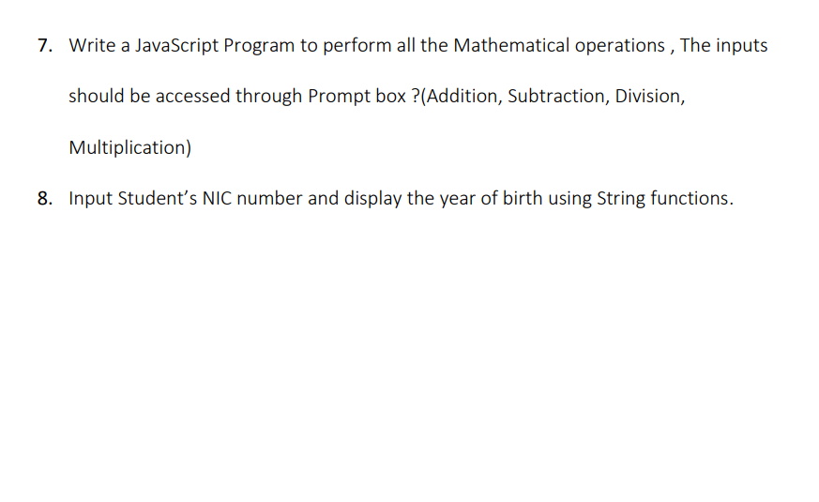

Exercise 07

<html>

<body>

<script>

function getInput(promptMessage)

{

return parseFloat(prompt(promptMessage));

}

function performAddition(a, b) {

return a + b;

}

function performSubtraction(a, b) {

return a - b;

}

function performDivision(a, b) {

if (b === 0) {

return "Error: Division by zero is not allowed.";

}

return a / b;

}

function performMultiplication(a, b)

{

return a * b;

}

function performOperations() {

const num1 = getInput("Enter the first number:");

const num2 = getInput("Enter the second number:");

const additionResult = performAddition(num1, num2);

const subtractionResult = performSubtraction(num1, num2);

const divisionResult = performDivision(num1, num2);

const multiplicationResult = performMultiplication(num1, num2);

const message = `

Results:

Addition: ${additionResult}

Subtraction: ${subtractionResult}

Division: ${divisionResult}

Multiplication: ${multiplicationResult}

`;

alert(message);

}

performOperations();

</script>

</body>

</html>

Exercise 08

<html>

<body>

<script>

function getYearOfBirthFromNIC(nicNumber)

{

if (nicNumber.length >= 6) {

const yearDigits = nicNumber.substring(0, 2);

const currentYear = new Date().getFullYear();

const currentYearLastTwoDigits = currentYear.toString().substring(2, 4);

const birthYearPrefix = (yearDigits <= currentYearLastTwoDigits) ? "20" : "19";

return birthYearPrefix + yearDigits;

} else

{

return "Invalid NIC number.";

}

}

function displayYearOfBirth() {

const nicNumber = prompt("Enter Student's NIC number (YYMMDDXXXX):");

const cleanedNICNumber = nicNumber.replace(/\D/g, '');

const yearOfBirth = getYearOfBirthFromNIC(cleanedNICNumber);

alert(`Year of Birth: ${yearOfBirth}`);

}

displayYearOfBirth();

</script>

</body>

</html>